**TASK 6**

**PSEUDOCODE FOR ARMSTRONG NUMBER**

BEGIN

INPUT num

ASSIGN sum=0; copyofnum=num

WHILE num! =0

ASSIGN rem=num%10; sum=sum+ (rem* rem* rem); num=num/10

IF compofnum==sum

PRINT copyofnum & “is an armstrong number”

ELSE

PRINT copyofnum & “is not an armstrong number"

ENDIF

ENDWHILE

END

FLOWCHART

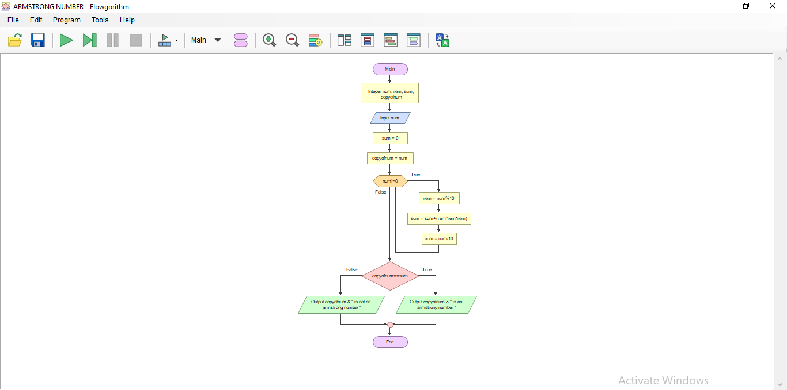

**CLEAR FLOWCHART**

